***CURRICULUM VITAE***

*of*

MD. AKHTARUZZAMAN

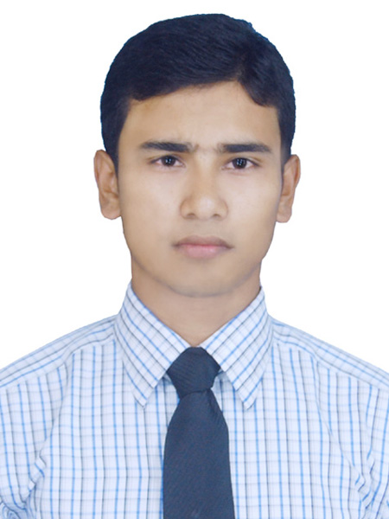

C/O: Md. Mahbubur Rahman

Vill- Poschim Debottor, Post- Singerdabri Hat

Thana- Rajarhat, Dist- Kurigram.

E-mail:- [akhtar92ripon@gmail.com](mailto:akhtar92ripon@gmail.com)

**Contact No- +88 01737-254875**

**Career Objective:**

To pursue a challenging career in a Dynamic Organization where the opportunity to utilize my knowledge and move my skills for professional career development. So, I would like to prove me as an energetic and hard working in my career.

**Academic Qualification:**

M.A (Masters) : 2015.

Subject : English.

Institute : Carmichael College, Rangpur.

Board/University : National University.

Session : 2014-2015.

Result : CGPA- 2.77 (On a scale of 4.00)

B.A (Hon’s) : 2014.

Subject : English.

Institute : Kurigram Govt. College, Kurigram.

Board/University : National University.

Session : 2010-2011.

Result : CGPA- 2.62 (On a scale of 4.00)

H.S.C : 2010.

Group : Business Studies.

Institute : Tista Degree College, Lalmonirhat.

Board : Dinajpur.

Session : 2008-2009.

Result : GPA- 4.10 (On a scale of 5.00)

S.S.C : 2008.

Group : Science.

Institute : Singerdabri Hat B.L High School & College, Kurigram.

Board : Rajshahi.

Session : 2006-2007.

Result : GPA- 3.38 (On a scale of 5.00)

**Personal Information:**

Name : Md. Akhtaruzzaman.

Father’s Name : Md. Mahbubur Rahman.

Mother’s Name : Mst. Amena Begum.

Present Address : Vill- PoschimDebottor, Post- Singerdabri Hat

Thana- Rajarhat, Dist- Kurigram.

Permanent Address : Vill- PoschimDebottor, Post- Singerdabri Hat

Thana- Rajarhat, Dist- Kurigram.

Contact No : +88 01737-254875

Date of Birth : 25/12/1992

Nationality : Bangladeshi (by birth).

National ID No : 19924917742000165.

Religion : Islam (sunny).

Gender : Male.

Marital Status : Married.

Blood Group : A+

Driving Licence No : KG0008624L00005

**Computer Skills:**

Excellent operating skills in Microsoft Word, Microsoft Excel, Power Point, Note and Internet Explorer.

**Language Skills:**

|  |  |  |  |  |
| --- | --- | --- | --- | --- |
| **Language:-** | **Reading** | **Writing** | **Speaking** | **Listening** |
| Bengali | Excellent | Excellent | Excellent | Excellent |
| English | Excellent | Excellent | Fluent | Well |
| Japanese | Well | Excellent | Well | Well |

**Experience:**

* Working as an Entrepreneur in DBBL Agent Banking at Mostofi Bus Stand, Sadar, Lalmonirhat from 15th January to till now.
* Two years’ experience as a Marketing Officer is about Agent Banking at DBBL Sub-Agent Outlet Point from 05th January 2017 to 30th December 2018.
* Working as an English Trainer at Alternative English Language Initiative (AELI) in Rajarhat, Kurigram from 15th December 2014 to 1st January 2017.

Signature



Md. Akhtaruzzaman